Plant Soil Moisture & Ph Sensing Alarm Using 8051

Plants need water as well as good soil (ph rich) to ensure proper plant growth. It becomes difficult to monitor these things manually each time to ensure proper growth and any ignorance may lead to bad planth health or plant decay/death. Here we propose an 8051 microcontroller base system that makes use of soil moisture sensor along with ph value sensor to constantly check for these values.

The system microcontroller ensures the plant gets proper moisture and ph by continuously monitoring for it. It also displays this on a display screen for user to monitor. Also the system is equipped with an alarm which sounds a buzz in case the values fall below a certain limit which may be bad for plant health. Thus the system ensures proper plant health using soil moisture and ph sensing.

Block Diagram:

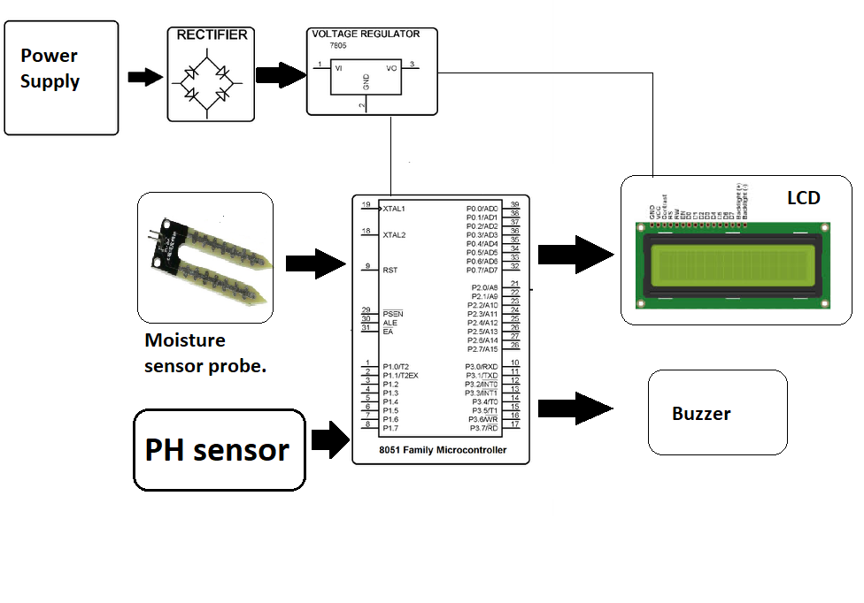

Hardware Specifications

- 8051 Microcontroller

- LCD Display
- Crystal Oscillator

- Resistors

- Capacitors
- Transistors

- Cables and Connectors

- Diodes
- PCB and Breadboards

- LED

- Transformer/Adapter
- Push Buttons

- Switch

- IC
- IC Sockets

Software Specifications

- Keil compiler
- MC Programming Language: C

